IT Officer
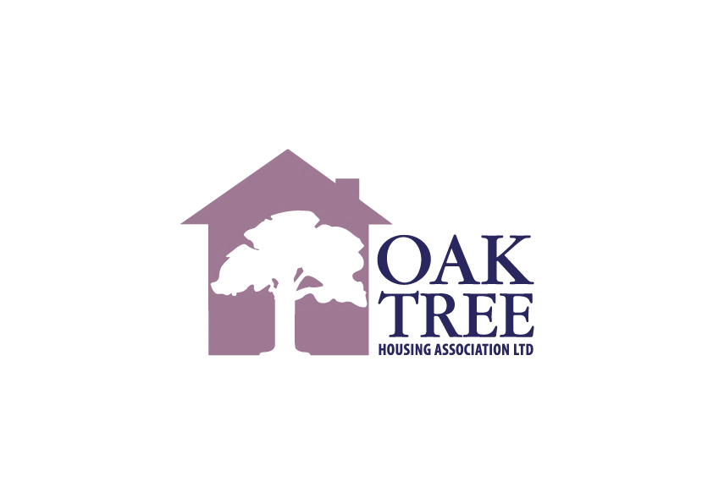
Oak Tree Housing Association
40 West Stewart Street, Greenock, PA15 1SH
Tel: 01475 807000

www.oaktreeha.org.uk



Our Vision
Building Better Futures

Our Values
Leadership
Accepting accountability and balancing vision with execution, leading by example and encouraging and developing the staff team to be the best they can be.

Customer Focus
When developing and providing our services, our tenants’ and other customers’ needs come first.

Team Working
By working together we develop our flexibility and resilience to ensure we provide a best value service to our tenants and customers.

Communication
Our communication is effective, accurate, up-to-date and easy to understand.

Respect
We treat our tenants, other customers and each other with respect and dignity at all times.

Integrity
Openness, honesty, transparency and trust are at the core of all that we do.

Index
Page

Job Description 2
Person Specification 5
Summary of Main Conditions 7
Key Dates 9
OTHA History 10
Committee & Staffing Structure 12

Job Description
JOB TITLE: IT OFFICER

RESPONSIBLE TO: IT MANAGER

GRADE: EVH GRADE 7 (PA22: £40,635.00 to PA25: £44,619.00 per annum)

(Increasing from 1st April 2026, in line with the 2026 pay review, to PA22: £42,707.00 to PA25: £46,895.00 per annum)

DATE REVIEWED: FEBRUARY 2026

  - Main Objectives

  - The IT Officer role will assist the IT Manager with the implementation of technology-based solutions that support organisational efficiency and productivity within Oak Tree Housing Association (OTHA) and any subsidiaries (as required).

  - The role will be responsible for areas such as data quality, reporting and analytics, as well as delivering day to day IT operations and user support. It will balance strategic data work with practical IT tasks

  - The post holder will play a key role within OTHA, ensuring staff and committee have the IT systems and equipment required to perform their individual and collective roles for the Association, in a secure digital environment, and in line with the Business Plan and strategic priorities.

2.0 Accountability

2.1 Directly accountable to the IT Manager and Director of Finance.

3.0 Core responsibilities - Data 60 percent (approx.)

3.1 Data Management and Governance

- Maintain and improve the data inventory, data dictionary and ownership model.
- Implement and enforce data quality standards and cleansing routines.

  - Reporting and Analytics

- Design, build and maintain management dashboards and operational reports.
- Translate business questions into data models and visualisations.

  - Business Intelligence Projects

- Support the IT Manager to deliver the IT strategy and digital roadmap projects.
- Support the IT manager in reviewing emerging IT technologies which will enhance service provisions and deliver operational efficiencies.
- Lead small business intelligence projects, automate routine reports and integrate data sources.
- Support tenant insight and Customer Experience (CX) analytics initiatives.

  - Data security and compliance

- Ensure data handling meets GDPR and internal policies, support audits and Freedom of Information (FOI) requests.
- Ensure compliance with industry standards including continuous risk assessment and risk mitigation, providing ongoing staff awareness and training sessions and continuous monitoring and auditing of systems.
- Assist with accreditation assessments and renewals (e.g.) cyber essential plus

4.0 Core responsibilities - IT 40 percent (approx.)

4.1 Endpoint and device management

- Manage device lifecycle, imaging, Microsoft Intune/Mobile Device Management (MDM) policies and patching schedules.
- Assist with all hardware and software maintenance, support & installations.
- Support the IT Manager with the procurement and implementation of required hardware and software.

4.2 Service desk and user support

- Provide 2nd line IT support, and excellent customer service, escalating to Managed Service Provider (MSP) where required, and maintain Service Level Agreements (SLA’s).
- Troubleshoot system and network problems, diagnosing and resolving issues promptly.
- Preparing and updating manuals and user guides including video user guides.
- Setting up new user accounts and password management.

4.3 Infrastructure and resilience

- Support on premise servers, backups, disaster recover tests and network monitoring; maintain asset register.

4.4 Collaboration tools and adoption

- Drive SharePoint and Teams adoption, create templates and run short training sessions.
- Oversee OTHA website and social media administration.

  - Security

- Implement baseline hardening, assist with Security Information and Event Management (SIEM) alerts and Multi Factor Authentication (MFA) rollouts.

5.0 General

- Develop strong working relationships with other colleagues, building digital confidence across teams, ensuring collaborative cross functional working and to maximise performance and enhance service delivery.

- Ensuring staff have the right tools and support to deliver services efficiently.

- To liaise with external agencies to further the Associations objectives and to promote the interests of the Association and its customers.

- Liaise effectively with staff in partner agencies to maximise performance and enhance service delivery.

- Attend training courses, seminars and conferences as required, keeping up to date with legislation and best practice.

- Assist in the implementation of the Associations Equality Policy and action plan as necessary. Promote and uphold the Associations commitment to diversity and equal opportunities in the decision and provision of services, in the procurement of services and in all policies procedures, activities and conduct.

- Promote and operate in line with OTHA’s workplace values, Leadership, Team Working, Integrity, Customer Focus, Respect & Communication

- Respond to emergency call outs where appropriate.

- Carry out any other duties as may be deemed necessary by the IT Manager and Executive Team.

Person Specification

Education, qualifications and professional memberships | Essential | Preferred
Extensive hands-on experience in Data and IT roles with demonstrable delivery. | √
Degree in Computer Science, Data Science, Information Systems. |  | √
Microsoft Certified: Data Analyst Associate, Azure Fundamentals, CompTIA Security+, or similar. |  | √
Cyber Security Certification |  | √
Skills, knowledge and experience | Essential | Desirable
Hands-on experience with various hardware, software, networks, and operating systems to troubleshoot issues and ensure optimal performance. | √
Strong knowledge of network administration, server management, cloud platforms, and various operating systems | √
Excellent knowledge of operating systems, Microsoft Office Applications e.g. Excel, Word, PowerPoint, Outlook etc. | √
Strong SQL skills and experience with a BI tool such as Power BI, Tableau or equivalent | √
Practical experience of Microsoft 365, SharePoint and Teams administration | √
Endpoint management experience with Intune, SCCM or similar | √
Experience of data governance and GDPR compliance in a UK context | √
Experience of validating data to ensure integrity | √
Good understanding of backup/DR concepts and basic networking | √
Practical experience of analysing, communicating and presenting complex IT information to a non-IT audience | √
Committed to a high standard of customer service | √
Analytical and methodical with strong attention to detail. | √
Solution focussed | √
Excellent communication skills verbal and written | √
Ability to keep calm in a crisis but meet work deadlines | √
Ability to work independently and organise own workload to achieve priorities and objectives | √
Comfortable working in a small IT team and with external MSP partners | √
Knowledge of housing management systems or public sector data sets. |  | √
Experience with Azure services and identity management (Azure AD). |  | √
Experience with Cyber Essentials |  | √
Experience with customer feedback platforms and CRM integrations |  | √
Scripting skills (PowerShell, Python) for automation and ETL tasks |  | √
Team Member Values and Attitude | Essential | Desirable
Motivated, enthusiastic and self-starter with commitment and drive for organisational improvement | √
Has a positive can-do attitude | √
Confident in own skills and abilities | √
Flexible and adaptable approach to work, ensuring deadlines are met | √
Friendly and supportive approach when working with others | √
Is committed to values of openness, honesty, integrity and respect | √
Proactive, pragmatic and able to prioritise competing demands | √
Collaborative team player who can coach non-technical colleagues | √
Empathise with others to see IT challenges from their viewpoint | √
General | Essential | Desirable
Prepared to undertake further training and qualifications, as required. | √
A flexible approach to work including working out with office hours when required. | √
Understands and is committed to Equality, Diversity & Inclusion (EDI) | √

Summary of Main Conditions

Oak Tree Housing Association is a member of Employers in Voluntary Housing (EVH) and the terms and conditions for this post follow the EVH terms. A summary of some of the principal areas are as follows:

Salary Scale:

The current salary scale for this post is EVH GRADE 7 (PA22: £40,635.00 to PA25: £44,619.00 per annum)

The salary is paid by direct credit transfer monthly, normally on 23rd of each month.

Contract Type:

Full-Time, Permanent

Hours of Work:

Normal hours of work are 35 hours per week, Monday to Friday.

*Please note the office is open to 6pm on a Tuesday and closes at 4pm on a Friday.

Holiday Entitlement:

25 days annual leave and 15 days public holidays per annum

Place of Work:

40 West Stewart Street, Greenock, Inverclyde, PA151SH.

Pension:

Oak Tree Housing Association is a member of the Scottish Housing Association’s Pension Scheme. Subject to terms of the scheme, we offer a defined Contribution scheme, with the option of an employee contribution of minimum 3% - 16%, with the OTHA contribution being 12%. Please note that life cover is included in the employer contribution.

Notice Period:

By employee: 1 month

By OTHA:

(i) continuous service under 5 complete years ~ 4 weeks.
(ii) continuous service of 5 years and over ~ 1 week for each complete year of service, up to a maximum of 12 weeks.

People Benefits:

OTHA currently offers an excellent working environment where we put staff health and wellbeing at the forefront.

Our People benefits currently include, Hybrid and Flexible working Polices, Family Friendly Policies, ongoing Health & Wellbeing initiatives, staff health checks (at 2 yearly intervals), support towards prescription glasses (currently £115.00) annual staff teambuilding day, EAP including a free counselling service, Professional Membership Fee’s, a Learning & Development Culture, free fruit for staff delivered weekly and discounted membership to Inverclyde Leisure.

This summary is for general guidance of applicants and will not form part of the contract of employment.

Any offer of employment will be subject to the receipt of two satisfactory references.

Closing Date: | 4pm, Tuesday 24th February 2026
Interviews: | Week Commencing: Monday 2nd March 2026

OTHA History

Oak Tree Housing Association Ltd was formed in April 2001 as a result of the merger of Bow Farm Housing Association and James Watt Housing Association. Victoria Housing Association then joined the new organisation at the end of June 2001. The three associations chose to come together for a variety of different reasons but primarily to create an organisation which was stronger than the sum of its parts and had an effective long-term future.

Over the years, we have successfully completed over 60 house-building projects and now have 1960 properties worth in the region of £97m. Around 83% of these new homes were provided for social rent, with the remainder offered for low-cost home ownership and outright sale on a shared equity basis. We have also invested in making our neighbourhoods attractive places to live, and 82% of our tenants are satisfied with our approach.

We have a track record of delivering highly effective and innovative services. We always strive to achieve a balance between quality and value for money, offering some of the lowest rents in Inverclyde. Nearly 80% of our tenants tell us they are satisfied with the value for money of their rent, and almost 90% of new tenants sustain their tenancy. We have high levels of operational efficiency as evidenced by relatively low re-let times, arrears and bad debt ratios.

We have grown our services over the years to reflect the changing needs of our local community. This has included for example: purpose-built accommodation for a local Women’s Aid service; partnering to deliver a local employment and training projects; establishing the Inverclyde Common Housing Register; engaging specialist tenancy support services for our most vulnerable tenants; employing Energy Activators to deliver energy advice and resource efficiency tips to tenants; and providing our tenants with access to local, independent welfare rights, advice and support.

In 2013, following significant financial and governance concerns at locally based Cloch Housing Association, we entered a formal partnership arrangement with Cloch and formed a group structure whereby Cloch became our subsidiary.

In 2019, as part of our Group business planning process, we took the opportunity to review the effectiveness of the partnership and following a comprehensive option appraisal, both Management Committees decided unanimously that it was now the right time to dissolve the partnership and allow each organisation to pursue its own goals. This decision was later ratified in a ballot of Cloch’s tenants, and our group structure was dissolved at the end of 2020/21.

As a result of our working relationship, we will continue to consider joint procurement projects, undertake joint research and deliver projects together, where these initiatives will result in improved efficiencies and better outcomes.

Whilst latterly we developed a shared services model for Finance and IT services, this ended on 28th February 2022. IT services continue to be provided to OTHA until 31st March 2026 from Cloch, via a Service Level Agreement.

Committee & Staffing Structure

The Association is managed by a Committee of Management made up of 11 members (maximum of 15) and operates currently through two sub-committees as follows:

Management Committee

Finance, Staffing & General Purposes Sub Committee
Housing & Technical Services Sub Committee

All sub-committees meet on a quarterly basis.

Staffing Structure

Information on our staffing structure can be found here:

https://oaktreeha.org.uk/Staff/

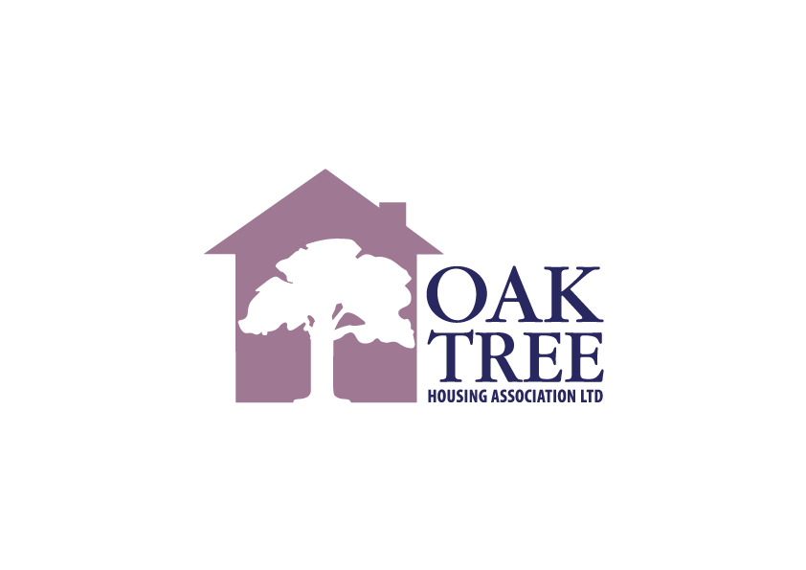

Oak Tree Housing Association
40 West Stewart Street, Greenock, PA15 1SH
Tel: 01475 807 000

www.oaktreeha.org.uk



